Report

1. **An introduction outlining the business problem**

The aim is to help the client’s Kickstarter campaign succeed. The client is a small board game company. They require $15000 at least as the goal. And they would like to expand the business, which means having more categories or sub-categories, wanting more backers.

An analysis, based on provided SQL file, should be implemented to set up a proper goal/backer expectation/category setting for this company,

1. **A description of the analytical process, including visualization.**
2. which parameters in SQL file should be taken into consideration. Based on tables in the SQL file, there are 13 parameters. There is no need to consider all these 13, as some of them can be ignored or merged. Campaign IDs and campaign names are unrelated parameters. Currency IDs can be used to transform the amount of goal and pledged, which can be ignored after transformation. Same as launched time and deadline time, they can be neglected after the calculation of campaign duration. As a result, there are 8 related parameters: outcome, goal, pledged, backers, country, duration, categories, and sub-categories.
3. what relationship these 8 parameters have with each other. Based on part 1, a relation chart can be made, shown in Fig.1. There are 6 relationships:

Fig. 1. The relation chart.

1. The relationship between goal and outcome. I divided goal data in two groups: successful and not successful, based on outcome. Tab.1 is the table showing sample number, average goal, and median goal with different outcome. Median was more suitable to represent the characteristics of their relationships, compared with average values. It is obvious that successful campaigns usually have lower goals. Same distribution shows in Fig.2.

|  |  |  |  |
| --- | --- | --- | --- |
| **OUTCOME** | **NUMBER** | **AVERAGE GOAL (USD)** | **MEDIAN GOAL (USD)** |
| successful | 5319 | 9859.94 | 4000 |
| not successful | 9681 | 109785.95 | 7000 |

Tab. 1. The table of outcome, number, average goal, and median goal.

Fig. 2. The relationship between goal and outcome

1. The relationship between backers and goal. According to the result of successful campaigns, the goal and backers have positive correlation. The larger goal needs more backers.

Fig. 3. The relationship between backers and goal.

1. The relationship between categories/sub-categories and backers. Based on Fig. 4, this plot showed the distribution of backers with different categories. In term of backers, the top 3 categories are 7, 13, 5, while the bottom 3 categories are 14, 15, 6. To order to get more backers, the companies can increase the ratio of the categories, whose IDs are 7, 13 or 5, in their campaigns. As for sub-categories, the top 3 sub-categories are 14, 8, 44, while the bottom 3 categories are 149, 131, 65.

Board game belongs to the category of "game". There are 8 subcategories in "game" category: 13. Games; 14. Tabletop Games; 44. Video Games; 66. Mobile Games; 70. Playing Cards; 113. Puzzles; 122. Live Games; 134. Gaming Hardware. Among them, 14. Tabletop Games (average backers 446), 70. Playing Cards (average backers 161) and 113. Puzzles (average backers 93.8) are board game items. The most successful board game campaign is Ghostbusters™: The Board Game with 250000 USD goal and 8396 backers.

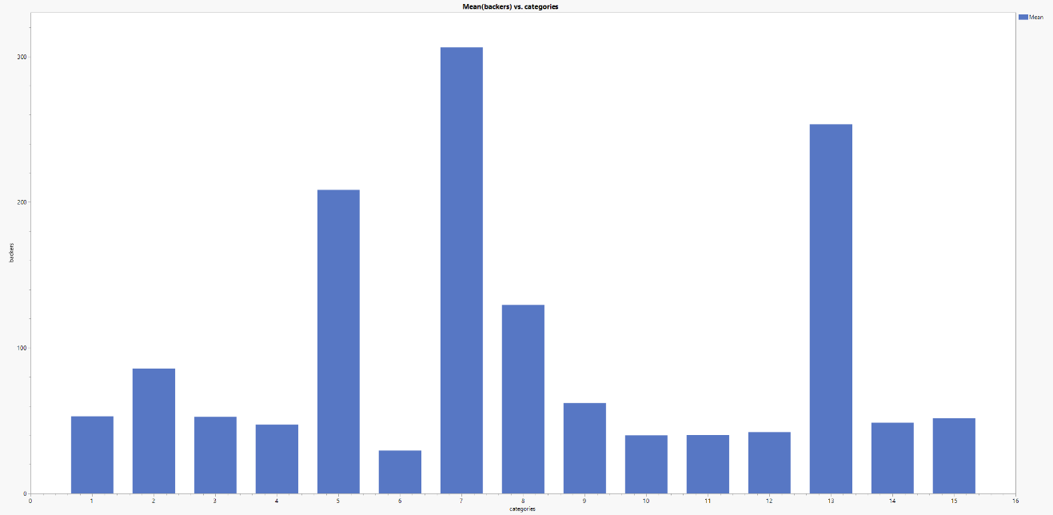

Fig. 4. The relationship between categories and backers.

Fig. 5. The relationship between sub-categories and backers.

1. The relationship between categories/sub-categories and goal.

Fig. 6 and Fig. 7. The relationship between categories/sub-categories and goal. Big pictures are attached in zip file.

1. The relationship between country and backers/pledged.

Fig. 8 and Fig. 9. The relationship between country and backers/pledged. Big pictures are attached in zip file.

1. The relationship between duration and goal. Shown in Fig. 10, the samples with high goals have median durations (ranging from 30 days to 60 days).

Fig. 10. The relationship between duration and goal.

1. **Final business recommendation for the 3 business questions**

First, based on the existing condition of the given company, $15000 is not a safe goal if the client want their campaign succeed. The proper goal should be about $10000, according to the analysis of the relationship between goal and outcome. To improve the goal, the company should optimize their sub-categories.

Second, if the goal is $15000, the company will need 406 backers, shown in Fig. 3. If the goal is $10000, the company just need 90 backers.

Thirdly, the board game belongs to the game category, which has the most backers (average 306 backers) among 15 categories. The average backers of board game campaigns are 401.

To sum up, if the company want to succeed with a goal of $15000, they will need 406 backers. As a result, the ratio of tabletop games should be larger than 88.6%, to guarantee enough backers..